PERFORMANCE ANALYSIS OF FM SYSTEM UNDER GAUSSIAN WHITE NOISE USING MATLAB
Objectives
1. To generate a Frequency Modulated (FM) signal in MATLAB using the specified carrier and message signal parameters.
2. To introduce Additive White Gaussian Noise (AWGN) into the generated FM signal and simulate the effect of a noisy communication channel using MATLAB.
3. To analyze the effect of AWGN on the transmitted FM signal by comparing the original and noisy FM signals using time-domain and frequency-domain analysis.
PROGRAM (MATLAB CODE)
clc;
clear;
close all;
% Parameters
fs = 100000;
t = 0:1/fs:0.02;
fm = 500; % Message frequency
fc = 5000; % Carrier frequency
kf = 100; % Frequency sensitivity
% Message Signal
m = cos(2*pi*fm*t);
c = cos(2*pi*fc*t);
% FM Modulation
fm_sig = cos(2*pi*fc*t + 2*pi*kf*cumsum(m)/fs);
% Add Gaussian White Noise
noisy = awgn(fm_sig,10,'measured'); % 10 dB SNR
% Display
figure;
subplot(4,1,1)
plot(t,m)
title('Message Signal')
grid on
subplot(4,1,2)
plot(t,m)
title('Carrier Signal')
grid on
subplot(4,1,3)
plot(t,fm_sig)
title('FM Signal')
grid on
subplot(4,1,4)
plot(t,noisy)
title('FM Signal with Gaussian White Noise')
grid on
OUTPUT:
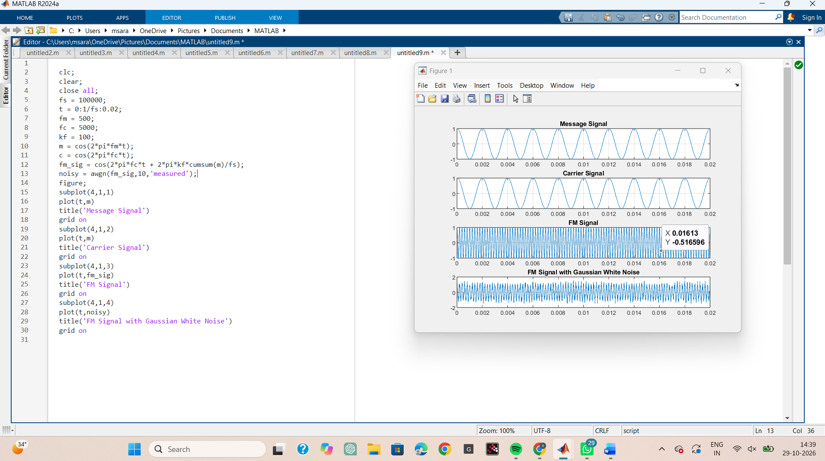
RESULT
1. Generated and visualized an FM signal using specified carrier and message signal parameters. 2. Introduced AWGN into the FM signal at a specified signal-to-noise ratio (SNR). 3. Compared clean and noisy FM signals in the time domain.
4. Computed the FFT and compare the frequency-domain characteristics of the clean and noisy FM signals.
5. Evaluated the influence of AWGN on the quality and spectral characteristics of the transmitted FM signal.
LABORATOR

